**Project Design Phase-II**

**Data Flow Diagram & User Stories**

|  |  |
| --- | --- |
| Date | 26-june-2025 |
| Team ID | LTVIP2025TMID30428 |
| Project Name | To supply left over food to poor |
| Maximum Marks | 2 Marks |

**Data Flow Diagrams:**

A Data Flow Diagram (DFD) is a traditional visual representation of the information flows within a system. A neat and clear DFD can depict the right amount of the system requirement graphically. It shows how data enters and leaves the system, what changes the information, and where data is stories.

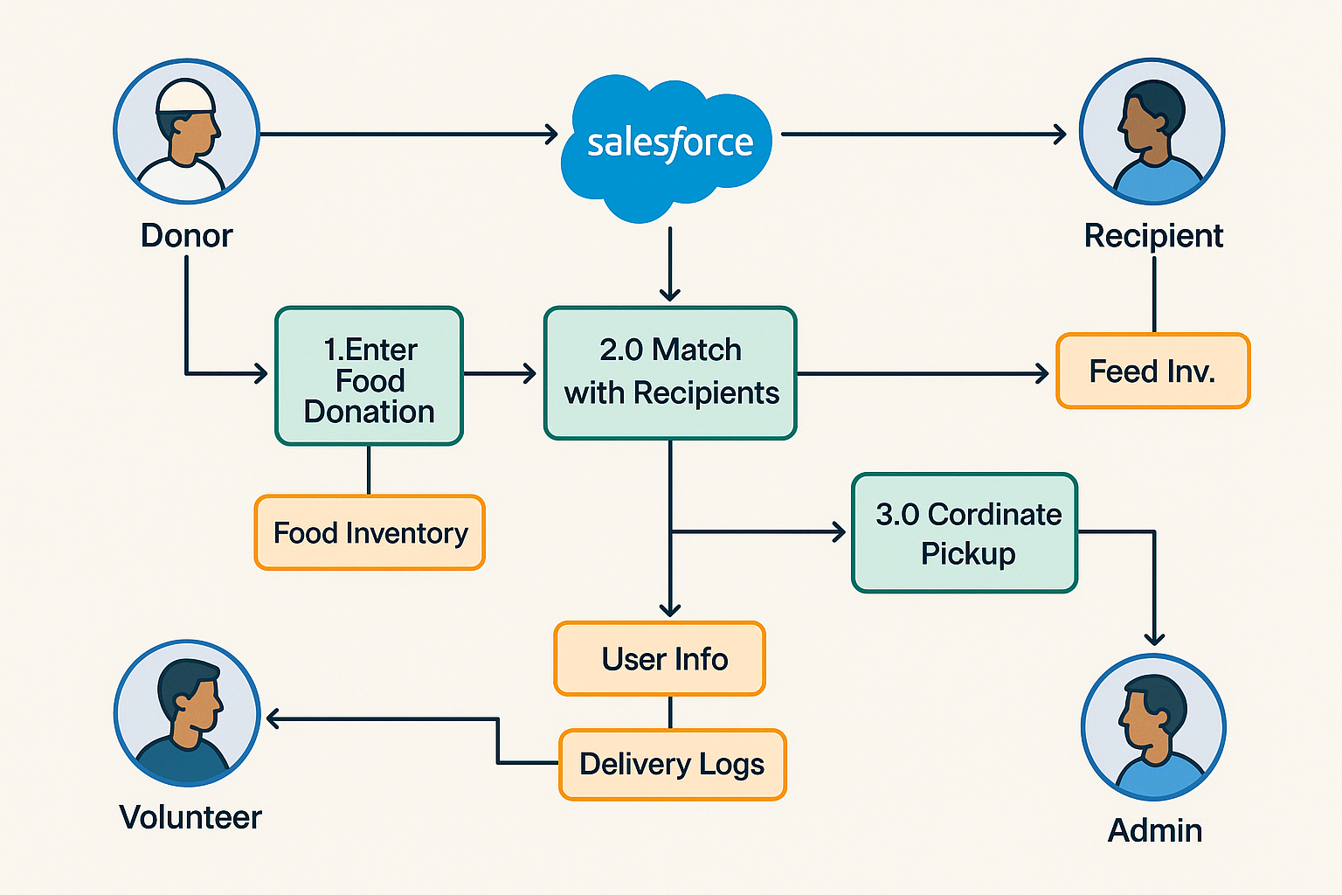

**User Stories**

| **User Type** | **Functional Requirement (Epic)** | **User Story Number** | **User Story / Task** | **Acceptance Criteria** | **Priority** | **Release** |
| --- | --- | --- | --- | --- | --- | --- |
| **Donor (Restaurant)** | **Food Registration** | **USN-1** | **As a donor, I can register available leftover food with details** | **Food is saved and listed for volunteers** | **High** | **Sprint-1** |
| **Volunteer** | **Pickup Management** | **USN-2** | **As a volunteer, I can view nearby food pickups and accept one** | **Volunteer receives pickup details** | **High** | **Sprint-1** |
| **Receiver (NGO/User)** | **Request Food** | **USN-3** | **As a needy person or NGO, I can request food or view food distribution schedule** | **Food request is logged** | **Medium** | **Sprint-2** |
| **Admin** | **User & Delivery Management** | **USN-4** | **As an admin, I can monitor food status, assign volunteers, and view reports** | **Dashboard shows food flow summary** | **High** | **Sprint-1** |
| **Donor** | **Notifications** | **USN-5** | **As a donor, I receive confirmation when my food is picked up** | **Donor gets SMS/email update** | **Medium** | **Sprint-2** |
| **Volunteer** | **Proof of Delivery** | **USN-6** | **As a volunteer, I can upload proof after delivering food** | **Image/status update saved in log** | **Low** | **Sprint-2** |